**MCIS 6333_002 – Data Visualization Programming**

**Fall 2023 Dr. Esther Ledelle Mead, Professor**

**Assignment 4 (A4)** Module 4 12 points

**Instructions**: Work as a team to fill in your team and team member information. Then continue to work as a team to enter responses for each of the three sections: 1) DVs programmed in Python, 2) DVs programmed in R, and 3) Data insights. Do not change the file name of this template except for adding your Team Number and name at the end of "A4-MCIS6333_002" (for example, "A4-MCIS6333_002-Team_1-Bad-To-The-Bone.docx"). Do not remove any content from this template. **Before submission, be sure that all required components are visible on the final version of your file by expanding their edges as needed and by inserting extra space as needed. Be careful not to move around the objects on this document in a way that messes up the flow. As you add content, the items will be pushed down, which is fine, but be sure to not let any DVs get split up or caught in between two pages. Create as many additional pages on this file as necessary. Turning in work created by students/teams from a past semester will result in a score of zero (0) and an official Academic Dishonesty and Integrity Violation report for each team member to the SAU Authorities.**

**Team #: __1__ Team Name: _____DATAVANA______________________  
   
 Contributed effort to this A4? *(Y or N)***

**Team Members (*full names are required*): *Answer required for each team member):*  
1. _________ANUSHA PAKKIRU_______ __Y__  
2. ____REVANTH KUMAR MADASU _____ __Y___**

**1) Data visualizations (DVs) programmed in Python that show the Histograms, BoxPlot, Bubble chart of Data Distributions based on Income Range, Internet usage, Education Level, Age, Gender**:

**2) Data visualizations (DVs) programmed in R that show the Histograms, BoxPlot, Bubble chart of Data Distributions based on Income Range, Internet usage, Education Level, Age, Gender**:

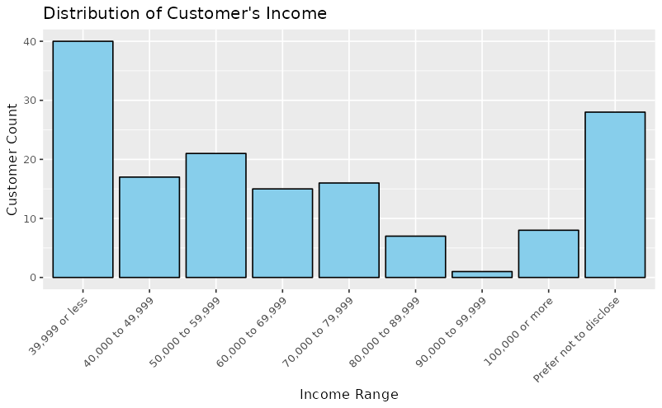

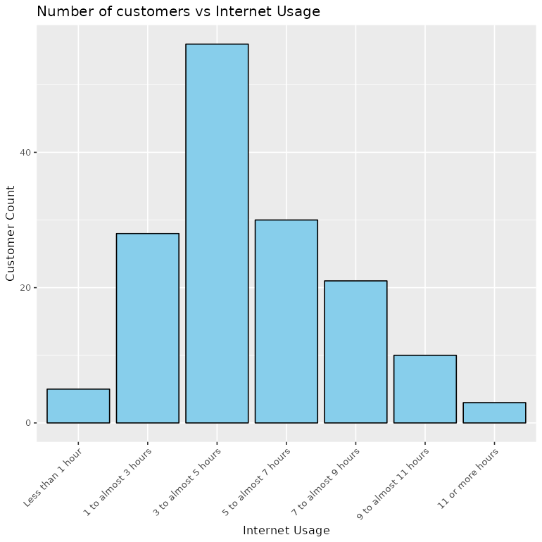

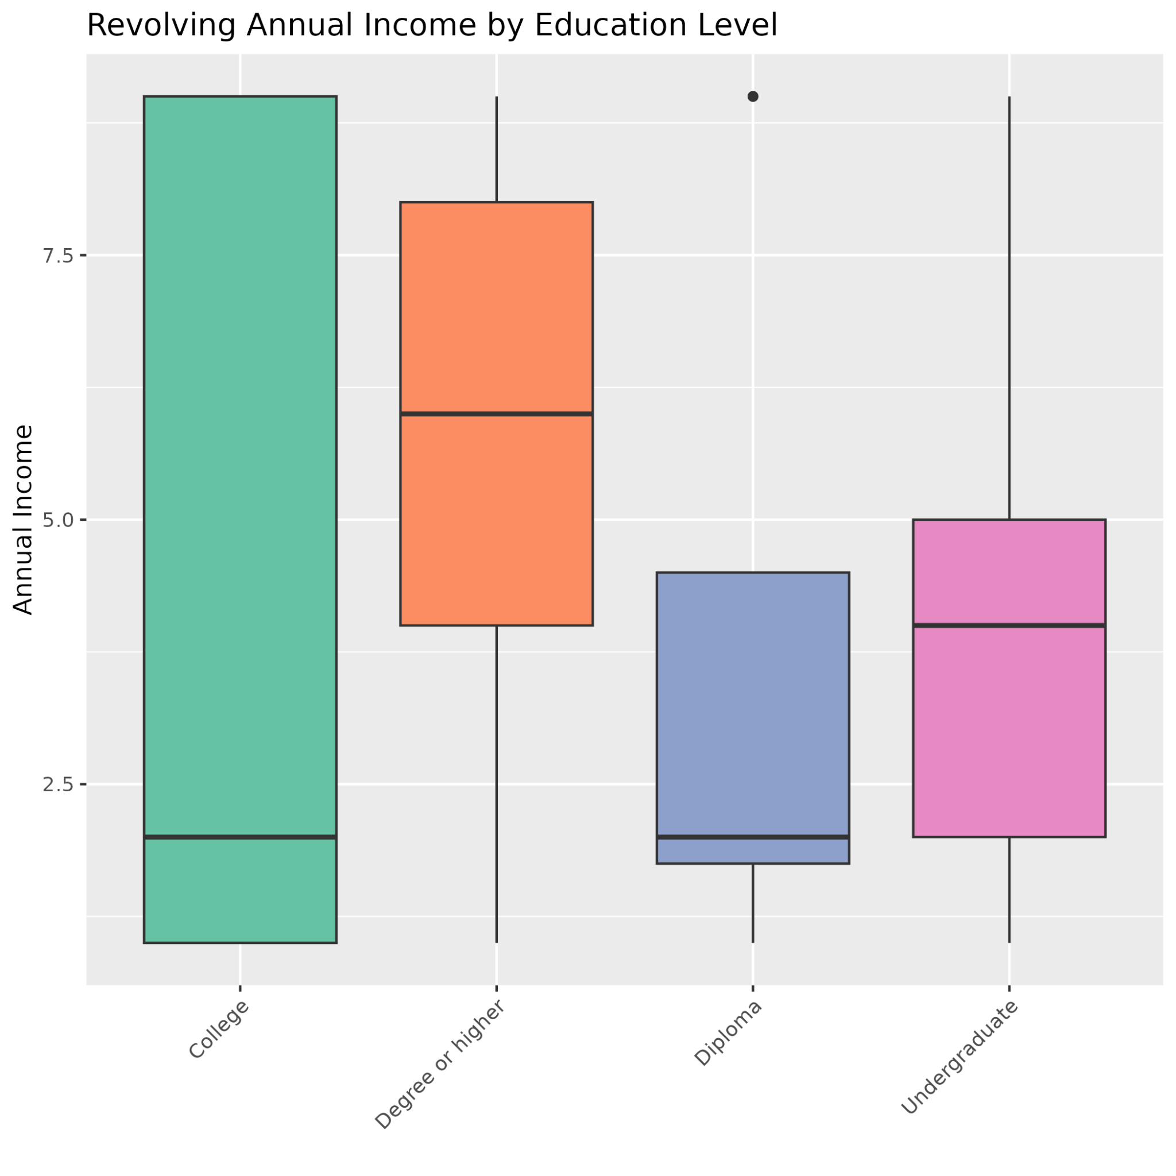

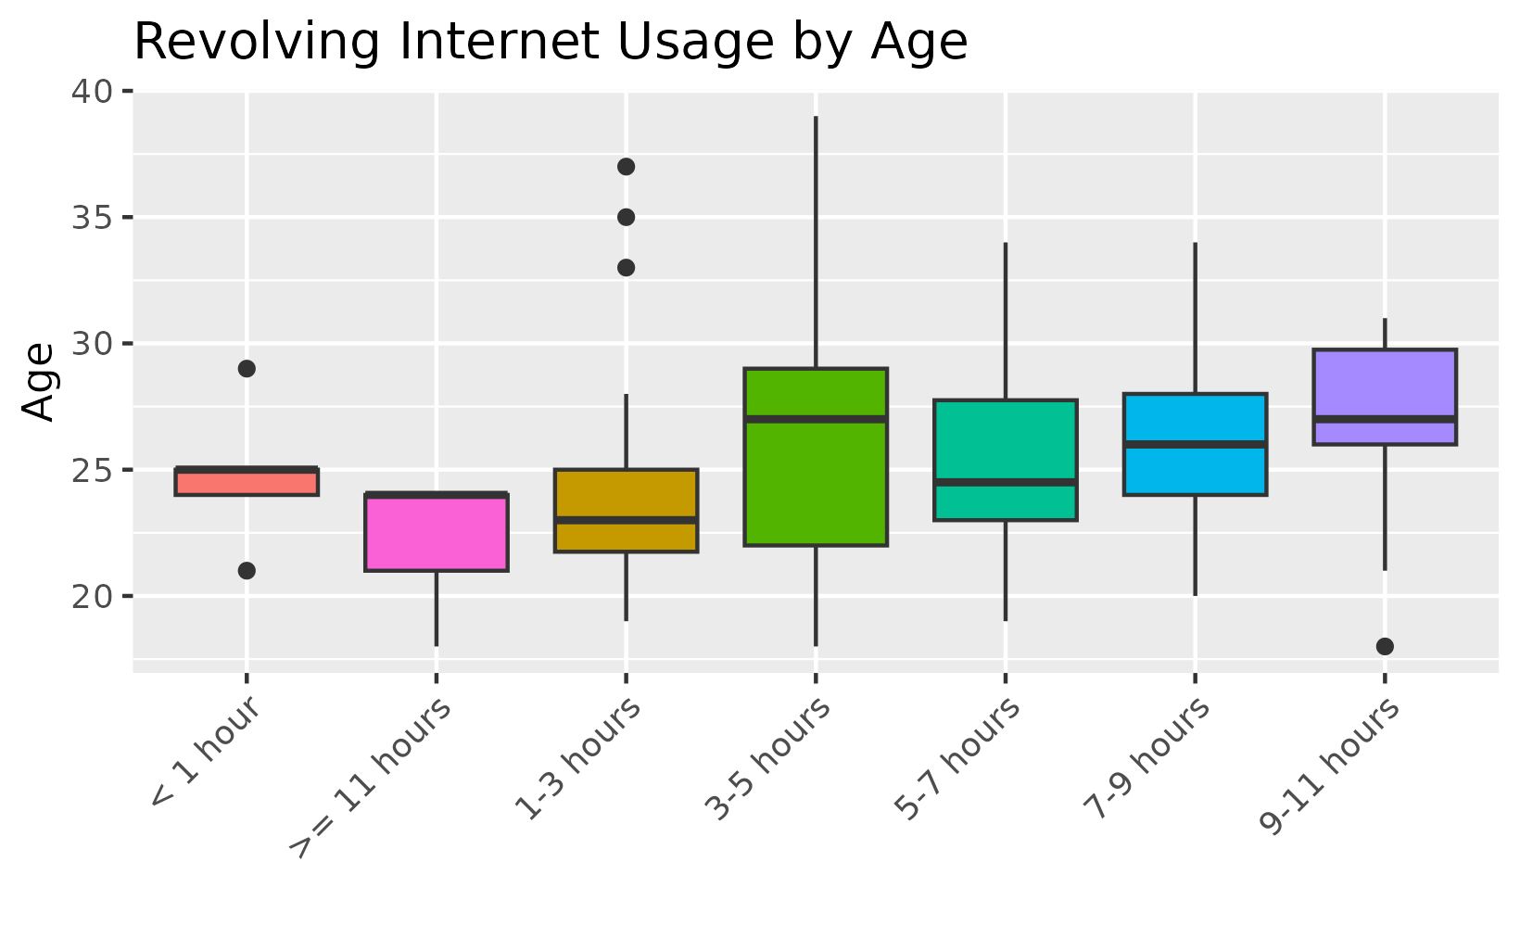

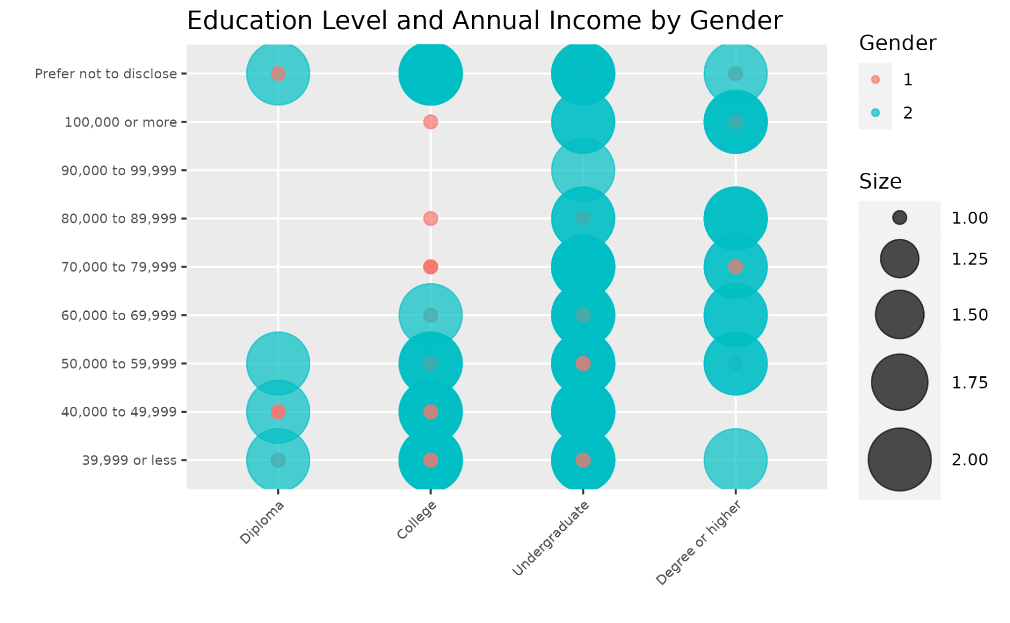

**3) Data insights:**

Below this text instruction line, insert at least three properly structured and arranged sentences (grammar, spelling, sentence casing, use of spacing, symbols and punctuation) to compose some data insights that can be logically deduced from the DVs that you provided above and **that say something about the data with regard to the M4 theme of Data Distributions**. If you write more than three sentences, be sure to use appropriate paragraphing structure for technical writing[1]. Do not remove this instruction block content.

i) From the data visualizations under Distribution of customer’s income, income groups less than 39,999 is the majority with a count of 40 customers,

ii) From the data visualization under Number of customer’s vs Internet usage, the group with 3 to 5 hours of internet usage is the largest with 55 customers. It is about 50% larger than the next highest group with 5 to 7 hours of internet usage.

iii) From the data visualization under Revolving internet usage by age, age groups of 20-30 years use internet more than 3 hours.

**MCIS 6333_002 – Data Visualization Programming**

**Fall 2023 Dr. Esther Ledelle Mead, Professor**

1. <https://developers.google.com/tech-writing/one/paragraphs>